RI Science Teachers Association is Pleased to Introduce our 2017 Conference Keynote Speaker

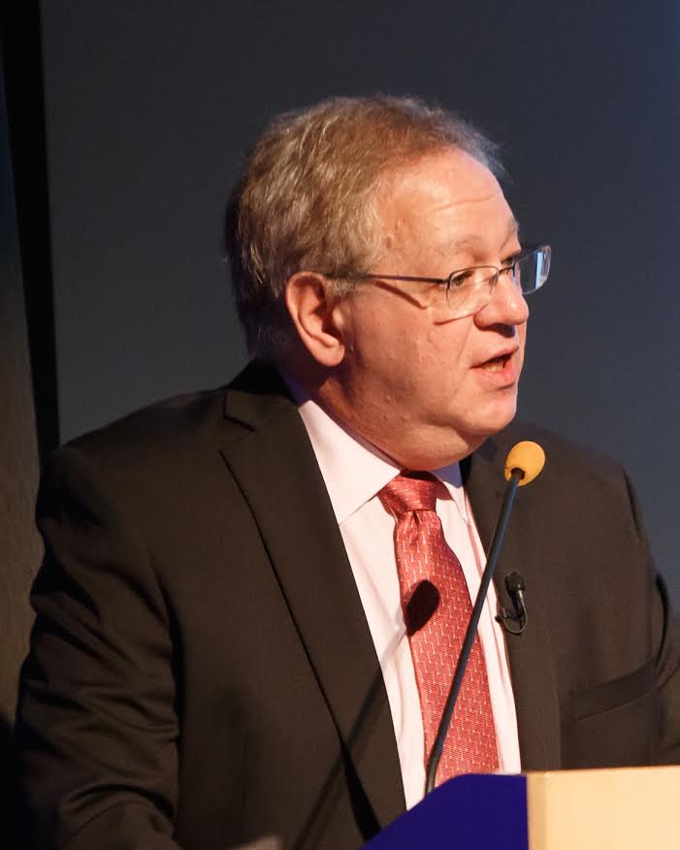
Brian J. Reiser is professor of learning sciences at Northwestern University. Dr. Reiser’s research examines how to make the scientific practices of argumentation, explanation, and modeling meaningful and effective for classroom teachers and students. Reiser co-led the development of IQWST (Investigating and Questioning our World through Science and Technology), a three-year middle school curriculum that supports students in science practices to develop disciplinary core ideas. Reiser is a member of the National Research Council’s Board on Science Education. He has served on the NRC committees authoring the reports A Framework for K-12 Science Education (which guided the development of the Next Generation Science Standards), Developing Assessments for the Next Generation Science Standards, and Guide to Implementing the Next Generation Science Standards. Dr. Reiser has also worked with Achieve on tools to support implementation of NGSS. Dr. Reiser is currently collaborating with several state initiatives to design and provide professional development and to develop curriculum materials for K-12 teachers to support them in realizing the reforms in NGSS in their classrooms. Dr. Reiser earned his Ph.D. in cognitive science from Yale University.

